Lehigh Valley Yankee Fan Club, Inc.
Bus Trip to Gettysburg
Saturday, October 7th, 2017
Cost: $95.00 – Per Person
( $50.00 Deposit Per person )

(Includes)
Gettysburg Battlefield
Mr. Ed’s Elephant Museum & Candy Emporium / Hickory Bridge Farm (Lunch)
Boyer Cellars Winery

1). Battlefield Tour: You will be guided by a trained and licensed Battlefield guide from the comfort of your private climate-controlled motor coach. Along the way you’ll get off of the bus several times to experience the hallowed grounds. This is a 2 hour long tour.

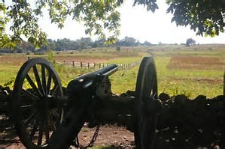
2). Mr. Ed’s Elephant Museum and Candy Emporium: You’ll never forget Mister Ed’s Elephant Museum, featuring more than 12,000 pachyderm figurines, circus souvenirs, political paraphernalia, toys and more. But don’t forget to be a kid in a candy store with more than 700 varieties of your favorites from yesteryear through today. You got no try our more than 70 flavors of creamy homemade fudge and our fresh roasted jumbo peanuts.
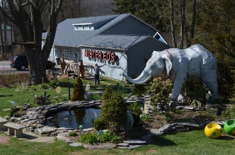

3). Hickory Bridge Farm (Lunch): Enjoy family-style meals with fresh ingredients and local wines.
The restaurant is located in a beautifully restored 165 year old barn surrounded by country land.
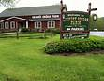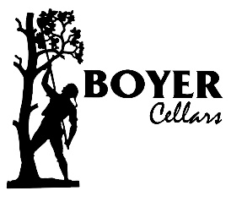

4). Boyer Cellars is a tasting room located in the Boyer Nurseries' garden shop.
In partnership with Matt Cimino, winemaker at Great Shoals Winery - Boyer Cellars sells a variety of red and white wines, hard ciders, and sparkling wines. The tasting room features a chestnut wood tasting bar, as well as a large, brick wrap-around porch with scenic views of the orchard and neighboring farms.

